2022 Accessibility Improvement Plan for the Data Standards Chair

Disclaimer
This report is not intended to be relied upon by anyone other than The Department of the Treasury, of whom the Data Standards Chair is an official. We prepared this report solely for The Department of the Treasury’s use and benefit in accordance with and for the purpose set out in our Proposal and Contract with Treasury dated 26 April 2022. In doing so, we acted exclusively for The Department of the Treasury and considered no-one else’s interests.

We accept no responsibility, duty, or liability:
- to anyone other than The Department of the Treasury in connection with this report
- to Treasury for the consequences of using or relying on it for a purpose other than that referred to above.

We make no representation concerning the appropriateness of this report for anyone other than The Department of the Treasury. If anyone other than The Department of the Treasury chooses to use or rely on it, they do so at their own risk.

This disclaimer applies:
- to the maximum extent permitted by law and, without limitation, to liability arising in negligence or under statute; and
- even if we consent to anyone other than The Department of the Treasury receiving or using this report.

Liability limited by a scheme approved under Professional Standards legislation

Purpose statement
About this report
The Data Standards Chair (Chair), an official of the Department of the Treasury (Treasury), commissioned PwC’s Indigenous Consulting (PIC) together with the Centre for Inclusive Design (CFID) to assess accessibility and usability as related to the Data Standards (also known as the Consumer Data Standards).
This report is the final output of the project.
Objectives of the report
The objective of this report is to provide findings of an Accessibility Review of the Consumer Experience (CX) Standards, and the Consumer Data Right (CDR) Consent Model. This Review was conducted on the Accessibility benchmarks identified in the Accessibility Obligations and Conventions Framework for the Data Standards Chair (Background Report), previously delivered to the Chair.
The other objective of this report is to outline an Improvement Plan, which consists of recommendations for the Chair, with the intent of prioritising and maximising efforts applied against the obligations outlined in the Background Report, and the findings of the Review.
Scope of this report
The report documents:
- Findings from the accessibility review;
- Findings from heuristics review;
- Outline of the prototype, including rationale and build details;
- Findings from consumer testing;
- recommendations to improve Accessibility, Usability, and Inclusivity within the CDR; and
- an improvement plan based on these recommendations.
The scope of this report does not include a comprehensive legal review, nor does it include a detailed implementation plan for recommendations.
The first draft version of this report was issued to Treasury in June 2022, with significant feedback being received from members of the Data Standards Body over a number of weeks.
The updated final version shared with Treasury on 05 October 2022.
Intended audience
- The Chair is the primary owner and audience of this report, and they can use the report to guide decisions about Accessibility, Usability, and Inclusion. The report is also intended to be published and shared with external stakeholders as part of the Chair’s requirements to consult.

Executive summary
The Chair has a legal requirement to ensure digital services are usable and accessible to people with disabilities (see the Disability Discrimination Act 1992).

The legislative function of the Chair, an Official of the Treasury, is to make and review Data Standards that define the format and process for how Consumer Data Right (CDR) data is shared, including consumer data – in other words, how this is disclosed - under the CDR; with their consent. Informed consent is central to the operation of this Right. Consequently, if the process whereby a consumer grants their consent is inaccessible, then their Right is also inaccessible.

To support accessibility within the CDR, the Data Standards Chair (Chair), as an official of the Department of the Treasury (Treasury), commissioned PwC’s Indigenous Consulting (PIC), together with the Centre for Inclusive Design (CFID), to review accessibility obligations for the Chair, and provide recommendations to improve practice.
This review includes a Background Report, which outlines the Chair’s obligations and offers recommendations to improve Accessibility, Usability, and Inclusion within CDR.
To complete this review, a prototype for Consumer Testing was developed. Details of that prototype are outlined here, and the prototype has been delivered in whole to the DSB.
Building on the Background Report and the prototype, this report outlines the results of four aspects of review, including the CX Guidelines, the CX Data Standards, a heuristic review of the design system and consumer testing.
This testing identified five strengths of the current CDR: consistent visual language; screen reader accessibility; simple design; overall simple use of language and a clear way out. These offer a strong base on which to build improvements to strengthen the CDR.
The review also identified a number of areas for improvement, covered in the recommendations summarised on the next page. A roadmap which includes considerations around priority of recommendations is given in the last section of this document.
Taken together, these results offer powerful insights to inform recommendations for the Chair to improve practice and continue to take a leading and influential role within the Australian Government and the economy in relation to data access and use for consumers.

Summary of Recommendations
This report includes seven recommendations:
Recommendation 1: Whilst the CX Standards already mandate certain Web Content Accessibility Guidelines (WCAG) criterion, the Chair should consider more extensively incorporating WCAG into the Data Standards, the Data Standards artefacts themselves, and related products, to address their legislative obligations for Accessibility.
Recommendation 2: Given the current reliance upon a Design System which is not fit-for-purpose, the Chair addresses the divergence from the GOLD Design System.
Recommendation 3: The Chair commissions a scoping-study into the development of Usability and Inclusivity framework(s) with the intent of addressing their legislative obligations.
Recommendation 4: The Chair, or the DSB, joins W3C in order to support the future direction of these standards.
Recommendation 5: The DSB should maintain an Accessibility, Usability, and Inclusion capability in order to support appropriate Data Standards development, on behalf of the Chair.
Recommendation 6: The Chair refines the existing CX Accessibility Standards in order to simplify and strengthen them.
Recommendation 7: Review, prioritise and address issues of Transparency, Clarity and Understanding and Visibility in the Consent Flow.
More detail of all recommendations and implementation considerations can be found in Section 7 of this report.

Contents

Purpose statement page 1
Executive summary page 2
Summary of Recommendations page 3
Contents page 5
1 Introduction page 7
2 Methodology page 9
3 Consent Model: WCAG Review of Flows page 10
4 CX Data Standards Review page 18
5 Heuristic Review page20
6 Consumer Testing page 24
7 Recommendations page 38
Appendix page 43
Appendix A User Research Methodology page 44
Appendix B Prototype outputs page 51

1 Introduction

1.1 What is the CDR
The legislative function of the Chair, an Official of the Treasury, is to make and review Data Standards that define the format and process for how CDR consumer data is shared – in other words, how this is disclosed – under the CDR; with their consent. Informed consent is central to the operation of this Right. Consequently, if the process whereby a Consumer grants their consent is inaccessible, then their Right is also inaccessible.
For a consumer to grant their consent to share their data, understanding their experience on how they access and use a data sharing product becomes crucial in developing products that enable them to access their Right. Accessibility, Usability and Inclusion is an Internationally recognised framework provides a solid foundation in creating a more accessible, useful and inclusive CDR. Accessibility, Usability, and Inclusion
Clearly Accessibility is a key part of making sure that all Australians can access the CDR, but it does not cover all needs. Considering Accessibility together with Usability through an inclusive design lens gives a more holistic picture of what the Chair can do to ensure Australians can access their rights under CDR.
Designing for Accessibility primarily addresses the needs of people with disabilities. Web Accessibility means that people with disabilities can equally perceive, understand, navigate, and interact with websites and tools. It also means that they can contribute equally without barriers. Accessibility standards are clearly outlined in Web Content Accessibility Guidelines (WCAG). Legislation and policy require compliance.
Designing for Usability means ensuring that digital products and services are effective, efficient, and satisfying for the people who use them. Usability includes user experience (UX) design. Unlike Accessibility, however, Usability does not explicitly consider the needs of vulnerable consumers. Because Usability generally considers developing better products and services for the mainstream consumer needs, research insights and product decisions tend to skew towards mainstream societal needs. In order to design for vulnerable cohorts, Usability needs to be applied with an Inclusive Design perspective.
Inclusive design means creating products and services that support people of all backgrounds and abilities to successfully achieve desired outcomes. Inclusion addresses a broad range of issues including accessibility for people with disabilities; geographic location; culture; access to and quality of hardware, software, and Internet connectivity; computer literacy and skills; economic situation; education, age; and language.
Unlike Accessibility, neither Usability or Inclusion have accepted international, or Australian, conventions that clearly articulate responsibilities to decision makers. As the Chair, and the DSB, consider embedding equal-access-of-use across the CDR’s access model, they should consider Inclusion in a broad sense. This would align with requirements under the Disability Discrimination Act (DDA), WCAG and the Australian Government Digital Service Standards.
This alignment would likely require the Chair to support research into developing a framework for the CDR that considers Usability and Inclusion. The Chair should consider using this as an opportunity to support a framework which considers accessibility across the entire CDR, while ensuring that the components of the CDR for which he is responsible are compliant.

1.2 Background to the Accessibility Review

Accessibility Review
The Data Standards Chair (Chair), as an official of the Department of the Treasury (Treasury), commissioned PwC’s Indigenous Consulting (PIC), together with the Centre for Inclusive Design (CFID), to review accessibility obligations for the Chair, and provide recommendations to improve practice.
This included a background report, and development and assessment of a prototype through consumer testing.
Accessibility obligations and conventions framework for the Data Standards Chair (Background Report).
In June 2022, PIC and CFID delivered a Background Report covering the Chair’s obligations for accessibility, including the future direction of these obligations, as they may relate to Data Standards,
• details of the obligations of the Chair related to Accessibility, Usability, and Inclusivity;
• a summary of current design standards, policies, and frameworks;
• potential future directions of accessibility standards;
• benefits and risks related to compliance; and
• recommendations to improve Accessibility, Usability, and Inclusivity within the Consumer Data Right (CDR).

The Chair has a legal obligation to meet accessibility standards
The Digital Transformation Agency (DTA) is the Australian Commonwealth agency that aims to provide strategic and policy leadership and investment advice and oversight to drive government digital transformation that delivers benefits to all Australians. DTA states that “You need to make sure everyone who needs your service can use it. This includes people with a disability, older people, and people who can’t use, or struggle with, digital services.” Supporting this statement, the DTA have included Accessibility as part of the Digital Service Standards which is a set of best-practice principles for designing and delivering government services.
Government services must be accessible to users regardless of their digital confidence, and/or access to a digital environment. This includes users in remote areas and users with different devices. This report considers accessibility and makes recommendations, and therefore is a part of the Chair discharging his duty as part of ongoing effort towards improving accessibility.
The Chair has a legal requirement to ensure their services, and by logical extension the digital services their services instruct, are usable and accessible to people with disabilities (see the Disability Discrimination Act 1992). Therefore, it is recommended that the Chair adopt WCAG to meet these requirements. There are multiple levels of compliance within WCAG, and the Chair needs to decide as to how to address these legal obligations. As a minimum standard, Australian Government agencies are currently required to meet the WCAG 2.0 Level AA . However, the Chair is expected to keep current with WCAG as it evolves. Consequently, it is strongly encouraged that the Chair support meeting WCAG 2.1 Level AA in order to provide a more accessible experience for users, and to help future proof the CDR against changes flagged in coming years for WCAG.

2 Methodology
The Chair commissioned PIC and CFID to assess accessibility and usability as related to the Data Standards. PIC and CFID worked as a collaborative team to complete an Accessibility Review of the CX Standards, and the CDR Consent Model. This Review was conducted on the Accessibility benchmarks identified in the Accessibility Obligations and Conventions Framework for the Data Standards Chair (Background Report), previously delivered to the Chair.
To complete the review, the PIC and CFID team completed:
1. Review of the Consent Model data flows with respect to WCAG. The context, methodology and findings for this are given in Section 3 of this report.
2. Review of the CX Data Standards: The context, methodology and findings for this are given in Section 4 of this report.
3. Build of a prototype, for use in user testing and to form the basis for future builds. Details of the prototype, including where to download relevant documents, code etc are given in Appendix B of this report.
4. Heuristics review. The context, methodology and findings for this are given in Section 5 of this report.
5. Consumer testing with relevant consumers. The context, methodology and findings for this are given in Section 6 of this report.
From these analyses, themes of insights and issues are developed and shared, including recommendations for addressing where appropriate. These were then analysed and combined to develop 7 recommendations to improve Accessibility, Usability, and Inclusivity within the CDR (three of these were already shared in the Background report).
These recommendations, including detail and prioritisation form Section 7 of this report, which is the basis of an improvement plan for the Chair to consider.

3 Consent Model: WCAG Review of Flows

3.1 Context
The consent, authorise and authenticate flow wireframes from the CX Guidelines – provided on Notion – was reviewed for Accessibility against WCAG 2.1 AA, as per the obligations identified in the Background Report.
The wireframes were developed by the CDR team to demonstrate the CX Standards and Guidelines in a product application that provides optional examples of key requirements and recommendations to help organisations build best practice consent models.
As the wireframes are artefacts for third party CDR developers, possible Accessibility issues need to be identified and communicated in order to prevent the unintentional promotion of Accessibility failures, and/or cause unnecessary re-work.

3.2 Methodology
The various elements reviewed included:
- Colour palette and accessible colour schemes that meet contrast requirements | - Use of imagery and images of text
- Typography and font selection | - Layout and logical read order
- Navigation, including drop down menus | - On focus buttons and form fields
- Heading levels and heading structure | - Error handling and alerts.
The findings are grouped into themes, which include common issues that should be considered when applying and implementing a WCAG compliant CDR.
Themes include both current issues identified through the review, and best practice reminders which may be minor or not currently issues, but which could emerge and should be kept front of mind in future design and development.
Themes have been given a severity rating of high, medium, or low. The rationale behind each rating is described below.
- A high severity issue indicates a roadblock. Someone with a disability will be completely unable to do an action on the website because of the accessibility Issue. Lack of keyboard control is a good example of a high severity issue.
- A medium severity issue means that the issue makes things difficult for someone with a disability. The action may be possible, but it is likely to be difficult or frustrating. Non-semantic labels for form field levels are a good example of a medium severity issue.
- A low severity issue means that while the issue technically fails WCAG 2.0, it is not an issue that’s likely to be too problematic. An example could be a decorative image having an unnecessary short alt text.
Adhering to the Department of Finance’s Gateway review methodology, a secondary accessibility review of the CDR consent model at its next development milestone would ensure the identified issues were resolved and no new issues had arisen and that obligations identified in the Background Report have been fulfilled.

3.3 Limitations
As this review was conducted on static wireframes there are some limitations to testing. Testing with assistive technology is not appropriate in this environment. The review covered all level A and AA success criteria that could be applied to the wireframes. We also sought to identify any expected flows that were missing in the wireframes.
The themes identified in this section were found through the review of the wireframes only (excluding focus order notes). Future review of these notes may address some of the issues identified in this report and should be considered as part of ongoing work.
While there are limitations from our initial wireframe review, these issues were then passed onto the prototyping team to resolve during the coded prototype development process.

3.4 Findings

Theme 1 – Colour contrast ratios
Severity | High  Current issue – the colour contrast ratio not explicit on all screens, insufficient contrast ratio will make the app unusable for people with colour blindness/low vision.
Flows, Screens, and devices effected | All flows, all screens, all devices
Issue Description | The colour of the visible focus indicator is not clear
Screen Capture | NA
Remediation Advice | Ensure that every focusable element receives a visible focus indicator. Ensure that the indicator is WCAG compliant
Selection Criteria Impacted | 2.4.7 Focus Visible, 1.4.1: Use of Colour https://www.w3.org/WAI/WCAG21/Techniques/css/C15

Theme 2 – Navigation
Severity | Medium  Best practice reminder – skip to main content is crucial to the usability of the app for screen reader users, Information displayed on each page such as headers and footers will be read repeatedly by the screen reader. This can be a frustrating experience for the user, and many may abandon the task.
Flows, Screens, and devices effected | All flows, all screens, all devices
Issue Description | Some pages do not allow people who navigate sequentially through content direct access to the primary content of the Web page.
Screen Capture | NA
Remediation Advice | Ensure all pages have “skip to main content “ function to allow screen reader and keyboard users to directly jump to the main content
Selection Criteria Impacted | 2.4.1: Bypass Blocks  https://www.w3.org/WAI/WCAG21/Understanding/bypass-blocks.html

Theme 3 – Contrast between text and background
Severity | Medium  Best practice reminder – ensure colour contrast is front of mind for developers and designers. If the contrasts ratio is not sufficient it will cause issues for users who are colour bind or have low vision.
Flows, Screens, and devices effected | All flows, all screens, all devices
Issue Description | The colour of the visible focus indicator is not clear
Screen Capture | NA
Remediation Advice | Ensure that every focusable element receives a visible focus indicator. Ensure that the indicator is WCAG compliant
Selection Criteria Impacted | 2.4.7 Focus Visible, 1.4.1: Use of Colour https://www.w3.org/WAI/WCAG21/Techniques/css/C15

Theme 4 – Page titles
Severity | High (due to number of potential occurrences)  Page titles are the first thing screen readers announce to the users. If missing the users cannot navigate properly and they may miss the context of the page. Missing titles directly impacts the WCAG guidelines.
Flows, Screens, and devices effected | All flows, all screens, all devices
Issue Description | Current issue – it is unclear if each page has a descriptive title
Screen Capture | NA
Remediation Advice | Ensure each page is appropriately titled and that screen reader announces that title
Selection Criteria Impacted | 2.4.2: Page Titles  https://www.w3.org/WAI/WCAG21/Understanding/page-titled.html

Theme 5 – Descriptive headings
Severity | Medium.  Headings are very general. Users will find it difficult to understand the context of the content underneath the heading. Effects all users. Directly impacts the WCAG guidelines.
Flows, Screens, and devices effected | All flows, all screens, all devices
Issue Description | Current issue – it is unclear if each pages utilises appropriate headings and labels
Screen Capture | NA
Remediation Advice | Ensure heading levels are used appropriately. Descriptive headings and titles work together to give users an overview of the content and its organisation.
Selection Criteria Impacted | 2.4.6 Headings and Labels  https://www.w3.org/WAI/WCAG21/Techniques/general/G130

Theme 6 – Locating content through search results in multiple ways
Severity | Medium.  It is crucial for the search results to be conveyed through a hidden field to enable screen readers to announce search results to users.
Flows, Screens, and devices effected | Consent Flow, DH selection 01 screen, all devices
Issue Description | Current issue – when consumers search for their provider, it should be possible for consumers to locate content in a manner that best meets their needs. It is not clear that there is a placeholder for that message.
Screen Capture | NA
Remediation Advice | Use screen reader only text stating “provider found” and anchor that text to provider label
Selection Criteria Impacted | 2.4.5 Multiple Ways  https://www.w3.org/WAI/WCAG21/Understanding/multiple-ways.html

Theme 7 – Radio button Focus
Severity | Medium  It is best practice to group the label with the radio button so that when the fields receive focus, screen reader will announce the label along with the button. If missing screen reader users will not be provided context of the radio button as the label will be read separately. Combining the views allows screen reader users to quickly navigate the entire view rather than having to skip through multiple sections of the same content.
Flows, Screens, and devices effected | Consent Flow, DH selection 01, all
Issue Description | Current issue – it is not clear if the Radio button and associated labels getting the same focus.
Screen Capture | 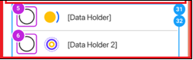
Remediation Advice | Ensure both Radio and Labels have single Focus
Selection Criteria Impacted | 2.4.7 Focus Visible  https://www.w3.org/WAI/WCAG21/Understanding/focus-visible.html

Theme 8 – Target size
Severity | High  This issue is relevant for smaller screens. If the button size is not as per the WCAG standard, various users will have difficulty using the button and completing the process.
Flows, Screens, and devices effected | All flows, all screens, all devices but emphasising mobile
Issue Description | Current issue – the size of the target area is unclear. Users need to be able to easily activate them, even on small handheld devices
Screen Capture
Remediation Advice | Ensure that touch targets are at least 44 by 44 CSS pixels. Provide a mechanism to change the size of the target independent of magnification.
Selection Criteria Impacted | 2.5.5 Target Size  https://www.w3.org/WAI/WCAG21/Understanding/target-size.html

Theme 9 – Focus Order
Severity | Medium  The flow of the page is unclear. The focus order should be intuitive for all types of users. If not than some users may not be able to access all the information and have the same experience as sighted users.
Flows, Screens, and devices effected | Consent flow, collection and use consent screen, all devices
Issue Description | It is unclear if the accreditation link receives focus. Similar observation for “learn more and other links”
Screen Capture | 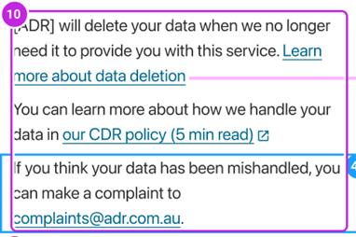
Remediation Advice | Ensure all links are part of the natural focus order. Top to bottom, left to right.
Selection Criteria Impacted | 2.4.3 Focus Order  https://www.w3.org/WAI/WCAG21/Understanding/focus-order.html

Theme 10 – Meaningful Link Text
Severity | Medium  The link descriptions are too general. Screen reader users will not be able to distinguish the information to pe provided by selecting the link. Users have no idea of what they are ‘seeing more’ of.
Flows, Screens, and devices effected | Consent and authorisation flows, all pages, all devices.
Issue Description | Best practice reminder – ensure link text identifies the purpose of the link without the requirement for additional context.
Screen Capture | 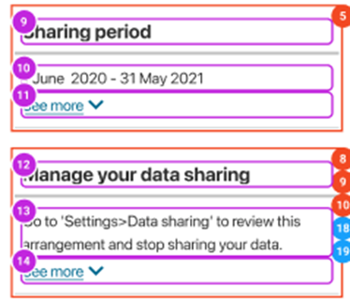
Remediation Advice | Ensure all links have screen reader only text that accurately describes the purpose of each link.
Selection Criteria Impacted | 1.1.1: Non text content, 2.4.4: Link purpose (in context)

Theme 11 – Text Spacing
Severity | Medium  Content spacing must meet WCAG criteria to ensure user has a good experience. If text is too tight this will be a problem for dyslexic users.
Flows, Screens, and devices effected | All, flows, all pages, all devices
Issue Description | Best practice reminder – it is unclear if content is readable and operable when users override author specified text spacing.
Screen Capture | NA
Remediation Advice | Ensure that loss of content or functionality does not occur when the user adapts paragraph spacing to 2 times the font size, text line height/spacing to 1.5 times the font size, word spacing to .16 times the font size, and letter spacing to .12 times the font size.
Selection Criteria Impacted | 1.4.12 Text spacing  https://www.w3.org/WAI/WCAG21/Understanding/text-spacing.html

Theme 12 – Heading Hierarchy
Severity | High (due to number of potential occurrences).  It must be clear that heading hierarchy is correct. If not correct the main content loses context. Heading structure assists in conveying information about the relationship of information.
Flows, Screens, and devices effected | All flows, all pages, all devices
Issue Description | Current issue – it is unclear if heading hierarchy is being followed.
Screen Capture | NA
Remediation Advice | Make sure Hierarchy of headings <h1> to <h6> is being followed as per the structure and relationship requirements.
Selection Criteria Impacted | 1.3.1 Info and relationships  https://www.w3.org/WAI/WCAG21/Understanding/info-and-relationships

4 CX Data Standards Review

4.1 Context
The CX Data Standards have been created to help organisations provide CDR consumers with intuitive, informed, and trustworthy data sharing experiences The CX Data Standards contain requires implementations by both Data Recipients and Data Holders to comply with the following:
- Data language Standards: Common | - Authentication Standards
- Profile Scope and Standard Claims | - Authorisation Standards
- Banking Language | - Amending Authorisation Standards
- Energy Language | - Notification Standards
- Accessibility Standards | - Withdrawal Standards
- Consent Standards

4.2 Methodology
The content of the CX Data Standards, and the Consumer Experience Principles, were reviewed in terms of:
- Accessibility
- Recommendations contained within the CX Data Standards; and
- The broader requirement of compliance with WCAG standards.

4.3 Limitations
Due to project timeline constraints, the CX Standards were assessed on a stand-alone basis by reviewing the content documented on the Consumer Experience page from Data Standards Github website. While the CDR team has developed prototype wireframes to demonstrate how the Standards are applied in a product, they were not included in the Standards Review. Accessibility is a consideration of the Data Standards, as it is mentioned in the Data Standards’ CX Principle 2: The CDR is Accessible and Inclusive.
The content and structure of the CX Data Standards on Accessibility, however, may inadvertently limit the capacity of CDR participants to deliver information and services that afford equal-access-of-use.

4.4 Findings

Issue theme 1: Language
The language ranges from clear to inconsistent in parts of the CX standards. In particular, the use of the vague phrase, “seek to comply”, which permeates this Data Standard provides extensive ‘wriggle room’ to negate any compliance requirements. “Seek to comply” is inconsistent with the obligations under the Disability Discrimination Act (DDA), and the Australian Human Rights Commission’s (AHRC) advice on how to achieve it.
The authors understand that “SHOULD”, used as per RFC2119, takes an active definition. However, users may not take this interpretation. The risk is that the use of the term “SHOULD” does not include clear expectations on Accessibility standards again provides extensive ‘wriggle room’ that could negate any compliance requirements, as discussed in Recommendation 6.
Recommendation | The Chair and DSB should consider changing the term to “MUST
Issue theme 2: Use of WCAG success criteria
The DSB has referenced the WCAG requirements from a guidelines level in the CX standards. Therefore, the CX Standards cover 5 out of 13 WCAG guidelines, which equates to 35 out of 78 WCAG 2.1 success criteria.
Additional success criteria, which are relevant, but are not explicitly mentioned include:
WCAG success criteria 1.4.10, which requires text and other content on a screen to reflow without requiring horizontal scrolling. This supports consumers with low vision including seniors.
WCAG success criteria 3.3.4, which is for Web pages that cause legal commitments or financial transactions for the consumer to occur, which modify or delete consumer-controllable data in data storage systems, or that submit consumer test responses, at least one of the following is true:
Reversible: Submissions are reversible
Checked: Data entered by the consumer is checked for input errors and the consumer is provided an opportunity to correct them; or
Confirmed: A mechanism is available for reviewing, confirming and correcting information before finalising the submission.
Recommendation | To create a more robust CX Accessibility Standard we have proposed to simplify the documentation of WCAG success criteria through an overall statement of assessment against the latest version of WCAG, as recommended in Recommendations 5 and 6.

5 Heuristic Review

5.1 Context
Design Systems are often used as a single source of truth for the design and development of digital products and services. Design systems comprise of a collection of reusable components which can be assembled together to build any number of screens. This ensures consistency across different use cases, scenarios and flows.
The DSB Design Library uses the GOLD Design System (formerly Australian Government Design System). Based on CX research, the DSB have customised existing components of the GOLD Design System to better suit the content and functionality required of the CDR Consent Model.

5.2 Methodology
A heuristic review of a design system is a way to test usability. In this review, the content of the DSB’s Design Library was reviewed by inclusive-user-experience design practitioners in terms of Usability and inclusive-design heuristics:
- Usability heuristics (Nielsen Norman Group)
- Inclusive Design dimensions (CfID, IDRC)
- Accessibility principles: POUR (W3C)

5.3 Limitations
Given time and budget constraints, this is a high level and strategic heuristic review rather than a detailed or comprehensive audit.

5.4 Findings
The DSB’s Design Library is a solid foundation for the CDR’s CX Guidelines in terms of style guide and information hierarchy. The findings report only the DSB’s Design Library elements that had issues. Others should be considered acceptable from a heuristics point of view.
This review identified three themes which can impact task completion and overall consumer experience, outlined in this section.

Issue theme Task orientation
Issue 1.1: Clarity on CDR governance and regulation
The www.cdr.gov.au website provides an explanation of the value of the CDR, (that it is easy to use and keeps your information safe). However, it is unclear who the CDR is governed by, and subsequently who ‘we’ refers to. As CDR relatively new and is not a well-known government institution (e.g., ATO), consumers may not trust it enough to proceed. Consumers expressed confusion about who was accessing their data, whether it would go to government and/or private financial entities/banks, and if so, what they might do with it.
Recommendation |  | Make the home page clearer and more transparent in terms of who makes decisions regarding data, how CDR data is accessed, how the CDR is governed and accessed by, and the value to the end user.  Use the CDR home page to build trust.
Evidence, examples and alternatives |  | 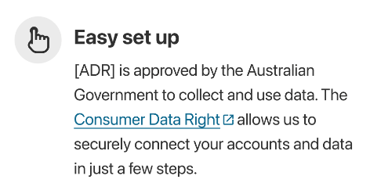
Issue 1.2: Visibility of flows
No visibility of steps or progress through the flow to help users orient where they are up to and how much more to go until form completion. We observed that most of the consumers dropped off before completing the flow.
Recommendation |  | Improve visibility of steps with indication of steps completed out of total steps and/or progress bar.
Evidence, examples and alternatives |  | [1CO 01.1] Consumers doesn’t know that a minimum selection of data clusters required to proceed.  [1CO DH Selection 01] CTA button is inactive until selection is made
Issue 1.3: Indications of process continuity
No clear indications of the requirements to continue when presented with options for selection. Consumers are more likely to make errors and need to back track. In the context of data privacy and consent, consumers should be provided with clear instructions about what they will be asked to do, and the information they will be asked to provide.
Recommendation |  | Include clear instructions or hints to help consumers understand what’s required to continue.
Evidence, examples and alternatives |  | For example, replace “Who is your provider” with “Select your bank”.
Issue 1.4: Form input fields
Consumers may need to select multiple options in single choice form input fields.
Recommendation |  | Review input fields and ensure they have appropriate flexibility for ease of use.
Evidence, examples and alternatives |  | [1CO DH Selection 01] Single choice radio buttons used for providers. What if consumers have multiple providers?
Issue 1.5: Information load
Information overload combined with a complicated form to complete.

Issue theme 2: Language
Issue 2.1: Jargon and unfamiliar language
Words and phrases used may confuse consumers due to jargon and unfamiliar concepts for the everyday consumer. Consumers with low English and financial literacy may struggle to understand what’s asked of them.
Recommendation | Use everyday language and terminology familiar with consumers’ existing mental models about financial data.
Evidence, examples and alternatives | [1CO DH Selection 01] “Who is your provider?”  Suggested alternatives for the example:  Select your bank.  Which bank do you have accounts with
Issue 2.2: Inconsistent language
Inconsistent language used for the same information about consent also causes confusion.
Recommendation | Whilst we understand that the Rules distinguish between various types of consent, this is confusing to consumers, therefore we recommend using consistent language in order to help consumers comprehend the process.
Evidence, examples and alternatives | [1CO Consent to collect] and [3AU Confirmation] asking for consent in different ways:  “Do you consent to us collecting and using your data? Consent / Deny”  “Do you allow us to share your data with [ADR]? Authorise / Deny”
Issue 2.3: Labelling of call-to-action buttons
Mismatch between the question asked and labelling of call-to-action (CTA) buttons adds friction.

Recommendation | Ensure CTA buttons are labelled meaningfully in the context of the page information or question asked.
Evidence, examples and alternatives | [1CO Consent to collect] “Do you consent to us collecting and using your data? Consent / Deny”  [4CMR2 DR Withdrawal 01] CTA button “Confirm stop access”  Suggested alternatives for the examples:  [1CO Consent to collect] “Do you consent to us collecting and using your data?” CTA: Yes / No  [4CMR2 DR Withdrawal 01] CTA: Yes, stop access

Issue theme 3: Accessibility
Issue 3.1 Colour contrast
Colour contrast of Dark theme palette fails AAA standards for regular text and graphics.
Recommendation | Ensure all foreground and background colour combinations pass AAA standards for regular text and graphics (in particular, Status colours: Dark theme).
Issue 3.2: Link labelling and locations
Multiple ‘Learn more’ links on a page which are directed to different link locations about different topics won’t be distinguishable to screen reader users.
Recommendation | Ensure all links on the same page have unique link labels if they take users to different locations.

6 Consumer Testing

6.1 Context
The CDR is designed to support consumers to make informed decisions. To test how this was working on the artefacts covered in this review, consumer testing was undertaken.

6.2 Methodology
Usability testing was conducted on the overall experience of users engaging with a new Consumer Data Right (CDR) flow prototype. Users were asked to interact and provide feedback on the consent, authentication and authorisation processes. This test focused on assessing the prototype’s accessibility, usability and clarity.
Ten individual users were recruited for the usability test, including: four Aboriginal and Torres Strait Islander consumers as well as six other edge users. Edge users are defined as people who are usually left out of the design process and/or experience barriers when accessing digital products. Testing was conducted in-person as well as remotely and asked participants to interact with the prototype. In-depth questions were also asked to generate discussion about their experience and to collect as much feedback as possible.
Participants were given fictional scenarios to test, related to:
- CompareBanks – a fictional Accredited Data Recipient (ADR) with a banking product comparison application (app), where consumers provide consent for their data to be shared in order to receive tailored banking products based on their banking information.
- Bank 1 – a fictional Data Holder (DH) used for the purpose of the scenario, where the consumer is requested to authorise disclosure of their banking data with CompareBanks.

6.3 Limitations
Due to timing and public health considerations, all testing was held online rather than face to face.

6.4 Findings
Five key themes around success, and four key themes relating to issues were identified, and described below.

Success themes

Success theme 1: Consistent visual language
The Design Library has been designed rigorously with consistent style guide and components.
There was good visual hierarchy in the prototype for different levels of information and visual indicators for buttons, input fields and alerts.

Success theme 2: Screen reader accessible
The consumers who relied on a screen reader commented on the apps’ ease of use.
For future implementation, we strongly advise working with accessibility professionals to provide the same level of WCAG compliance or investing in additional accessibility expertise within the DSB. This is in line with recommendation 1 of this report, adoption of WCAG standards.

Success theme 3: Simple design
The design of the prototype was modern, simple and did not overwhelm consumers.
This supported task orientation and overall usability.

Success theme 4: Overall simple use of language
For the most part, the language of the prototype was clear and direct. Although the concepts may be unfamiliar to consumers, there was not an overwhelming amount of jargon, or complex terminology.

Success theme 4: Clear way out
Consumers noted there was always a clear way in the prototype to exit the process or go back to make changes if needed.
This provides a level of control and ensures the user won’t get stuck.

Issues and opportunities for improvement
Issues and opportunities for improvement were identified and categorised by theme. They are described below, with recommendations for improvement. All evidence (such as screenshots) is from the coded prototype. Where findings might differ for wireframes or other artefacts, this is noted in text.
Issue theme 1: Transparency
Issue 1.1: Lack of understanding of the role of CDR
Consumers were tested on the understanding of the process.
Because the app said, ‘Comparebanks is approved by the Australian Government to collect and use data.’9 out of 10 consumers believed this conveyed that CompareBanks was from, and controlled by, the Government. Therefore, they believed they were sharing their data with the Government.
The consumers stated they were comfortable with their data being accessed by the Government but were confused why the Government was collecting their data this way.
Recommendation:  Improve Understanding | CX research should continue to be conducted to support the comprehensibility of data sharing, as well as consumer perceptions regarding trustworthiness and transparency of the CDR, as it relates to the Data Standards.

Issue theme 1: Transparency
Issue 1.2: Lack of trust
Consumers were not willing to share data with CompareBanks:
- There was a lack of trust in sharing personal information, especially financial data, with the website.
- Consumers said that they would exit the website, after the website requested to collect consumers' data for the next 12 months, because consumers assumed that the tool would request data from the past 12 months not the next 12 months.
- All consumers reported not feeling comfortable with the sharing period.
- Consumers felt like they were being asked to give too much data away.
- The product did not explain to consumers what would happen if they did not consent to share any of their data. There was also no clear explanation for how sharing their data would affect the outcome.
Recommendation:  Build trust | CX research should continue to be conducted to support the comprehensibility of data sharing, as well as consumer perceptions regarding trustworthiness and transparency of the CDR, as it relates to the Data Standards.
Evidence and examples  There was confusion as to the role of the Government in the data transfer and storage (see issue 1.1). | 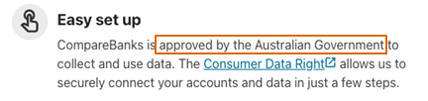
All consumers reported not feeling comfortable with data sharing
- Lack of trust in sharing personal information, especially financial data with the website.
- Consumers assumed that the tool would request data from the past 12 months, not the next 12 months.
- All consumers reported not feeling comfortable with the sharing period.
Consumers felt like they were being asked to give too much data away, because there was no explanation for why their data was needed, and what would happen if they decided not to share it.

Issue theme 1: Transparency
Issue 1.3: Safety
Consumers are very aware of the risks of sharing data online. Most of them, however, do not have a solution to share data safely online.
Consumers felt they were lacking the ability to safely input their data whilst protecting their privacy. The constant fear of having their personal information stolen, and this feeling of being unsafe online could potentially result in them not using such a product at all.
Physical safety was mentioned by consumers using this app, on mobile devices, in public spaces.
This was a common concern.
Recommendation:  Consider showing how the CDR recommends that participants address digital and physical safety. | - CX research should continue to be conducted to support the comprehensibility of data sharing, as well as consumer perceptions regarding trustworthiness and transparency of the CDR, as it relates to the Data Standards.
Evidence and examples
All participants hesitated on this page and were not sure if they would trust CompareBanks completely

Issue theme 1: Transparency
Issue 1.4: Control and Personalisation
Consumers voiced that they needed greater control in what data they shared. Consumers were willing to share more if they could choose from all the aspects of data sharing, not only the three general categories. This lack of control can lead to mistrust and disengagement if a consumer does not wish to share all their details.
Many participants reported that they use multiple banks for different purposes. There was no explanation or justification, however, as to why consumers could only select one bank.
Due to the complexity of consumers’ lives, there needs to be greater personalisation in the product in order to improve the accuracy and relevancy of the results.
Recommendation:  Allow more options within the process | - Allow for more personalisation options within the app while sharing the data.  - Consumers feel the need to be in control of their data.  - There needs to be a clear problem that the app solves for consumers.  - This should not be a one-size-fits-all product.
Evidence and examples  Consumers wanted to be able to choose the sub-categories in these sections. | 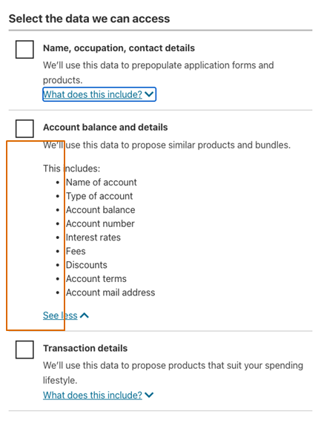
Need for ability to choose multiple banks, as consumers often use different banks for different reasons | 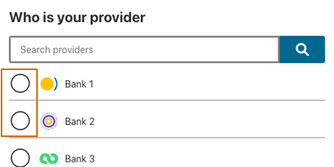

Issue theme 1: Transparency
Issue 1.5: Hesitation to share data online, especially from smartphones
When talking about the participant’s experiences of sharing their personal data online, participants were hesitant to share any data from their smartphones.
Participants were aware of what it means to provide consent to share data and wanted more control on where and when they shared their personal information.
Participants expressed feelings of being scared, lost, annoyed, concerned and not safe when talking about their experiences with data sharing.
Recommendation:  Provide more transparency around data sharing, and the roles of financial institutions and governments in CDR | - In the reviewer’s experience, consumers trust government products more with data than non-government products. Therefore, the perception of the role of government in CDR is important. The role of each party must be clearly communicated to the consumer user.  - When a “not trusted” site asked for data, consumers were likely to call the organisation so they could double-check the legitimacy of the product.  - Some consumers expressed that they would have liked for a regulatory body from the government that allows safe data sharing.  - The success of the product relies on participants understanding how and why their data is being shared. The Chair has an opportunity to lead this conversation and be transparent in how the data is being shared. As a trusted provider, people would turn to the government for advice.

Issue theme 2: Clarity and understanding
Issue 2.1: Instructions
All consumers struggled to complete the data sharing process, because there was a lack of instructions and no clear goal defined.
Consumers had no confidence of stopping their data from being shared without their permission. Consumers recommended including a settings menu in order for them to see how their data would be shared.
Most consumers were not confident that emailing an ADR would successfully stop their data from being shared. This is because of a history of poor data sharing and privacy enforcement in Australia with private business.
There is no clear explanation of their CDR Rights from the start, which led to confusion on multiple occasions.
Recommendation:  Provide clearer instructions | Create transparent communication for how long data sharing requests take to action.  Provide clear and straightforward information about data sharing, including:  - what it does,  - what the consumer can do,  - the aim of collecting this information,  - how sharing data can help consumers, and  - what will happen next with their data.
Evidence and examples  Participants had no confidence that emailing an ADR would work and requested that the app had faster ways of stopping data sharing. | 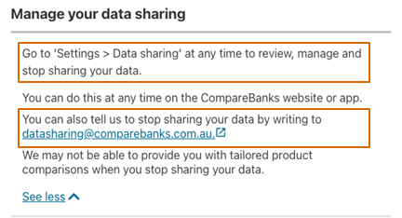
The explanation on the CDR website was not prominent enough to make the participants want to explore it.  Consumers did not know what CDR was, caused in-part by them scanning the page but not reading the full content. | 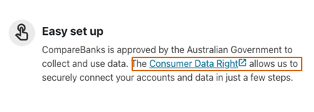

Issue theme 2: Clarity and understanding
Issue 2.2: Complex language
Consumers identified multiple instances of complex, or ambiguous, language throughout the scenario. Most of the scenario was reported as being easy to understand.
All consumers tested, however, were unfamiliar with the acronym ‘CDR’. One consumer suggested that it “would be clearer if [CDR] was spelled out”.
Additionally, the following words were reported as confusing:
  - Data: “… need other terminology, data can mean different things of not everyone knows exactly what it means.”
– Cognitive/physical mobility disability consumer.
  - Prepopulate: “… just use prefill!”
– Physical mobility disability consumer.
Recommendation:  Simplify language | Use simple language and sentence structures with icons and visuals, avoid using jargon or provide definitions and avoid long paragraphs.
Evidence and examples  The word “data” is ambiguous to consumers as it can have multiple meanings. | 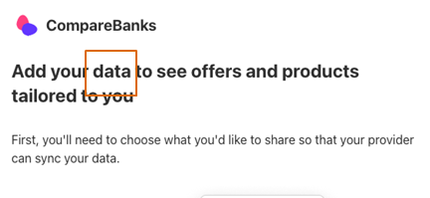
“Prepopulate” is seen as a complex word by participants. | 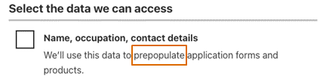
The CDR acronym is not common and caused confusion to consumers. | 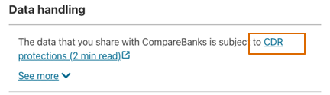

Issue theme 2: Clarity and understanding
Issue 2.3: Unclear content
Consumers would often scan the content instead of reading it word-by-word, and this was more prevalent with complex information. This scanning can be alleviated with imagery to complement the text.
Consumers commented that the illustrations were not appropriate for a banking tool. This led consumers to not value the images used in most of the prototype.
This also resulted in consumers ignoring the images, leading to poor consumer comprehension.
Recommendation:  Clarify content through effective use of imagery | Use images that add value to the content and use images/ infographics to help explain more difficult or complicated parts of the process.
Evidence and examples
Illustrations do not complement the flow.

Example of a hard-to-understand page that could benefit from an infographic explanation.  The white box is where the image, or infographic, should go. | 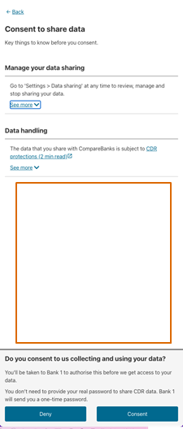

Issue theme 2: Clarity and understanding
Issue 2.4: Financial and digital literacy
Consumers noted that there is a large range of financial and digital literacy across the Australian population.
The majority of consumers felt less comfortable using a digital product for financial products and would prefer to talk to a representative from their financial institution.
Consumers perceived these representatives as experts with more financial literacy than themselves.
Digital literacy and access to digital technologies can also be a barrier for consumers. Most consumers felt more comfortable using their desktop/laptops than their smartphones to access this information.
The combination of low digital and financial literacy can lead to participants disengaging from this product.
Recommendation:  Provide omni-channel experience and education | - Provide consumers with an omni-channel experience to access this product.  - Ensure complex content has suitable explanations for consumers with low financial literacy and digital literacy.

Issue theme 3: Consistency
Issue 3.1: Input controls
Inconsistent language used for the same information about consent caused confusion. The facilitator in the session needed to set expectations multiple times for interacting with the controls.
Inconsistent placement of buttons throughout the product led to confusion with some consumers.
A consumer with a limb tremor expressed a need for larger clickable areas for interactable items (buttons and links), more time to complete tasks, and more error prevention.
There was an instance where the consumer clicked “Deny” by accident and was unable to easily go back to the correct option.
The terms ‘consent’ and ‘authorise’ reflects the rules, however in the context of consumer understanding the language can be misunderstood.
Recommendation:  Bring consistency to input controls | - Whilst we appreciate the distinction used by the Rules in order to distinguish between consent types, we recommend adopting consistent terminology to assist consumers in understanding the material quickly.  - Use larger buttons and click areas in order to allow consumers with difficulties in navigating small / mobile devices equal-access-of-use.
Evidence and examples  Inconsistent language used for buttons and instructions. | 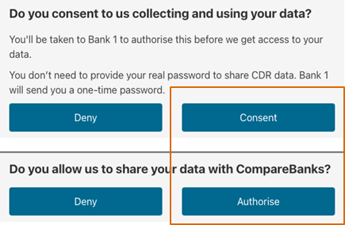
The small size of the call-to-action buttons in relation to the white space, made it hard to go back.
Note this screen shot is from the prototype. the CX Guidelines and wireframes have addressed this issue, and therefore this should be considered a best practice reminder in that instance.

Issue theme 4: Visibility
Issue 4.1: Inaccessible controls
Multiple consumers expressed interest in looking at the settings panel in the prototype to ensure that they would be able to control their shared data. The settings option, however, was not available in the prototype.
The consumers requested an auto-fill option on the login for the banking pages, which aligns with best practice Accessibility.
Recommendation:  Complete Consumer Testing | For CDR participants implementing the CX Data Standards and guidelines on their products, Consumer Testing for all features and functions should be conducted during Production Verification and Acceptance Testing
Evidence and examples  Consumers wanted the option to explore the settings before continuing the process. | 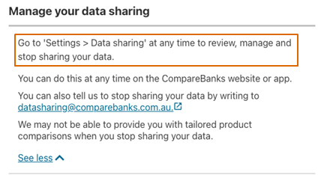
Need for an auto-fill option.

Issue theme 4: Visibility
Issue 4.2: Imbalance in white space
When testing on mobile and desktop, the consumers commented on the imbalance of the use of white space in the prototype.
Consequently, the text and images need to complement the white space on the page. Additionally, it would be useful to combine or split pages up, as necessary.
A consumer with a cognitive disability described the expanded accordion menu as "a wall of text," on the mobile device, but “easy to read” on desktop.
Consumers with physical mobility disabilities identified that scrolling can be a difficult task.
Recommendation:  For future iterations of the prototype, bring balance in white space use. Where appropriate, consider balance in white space in wireframes and the design library. | - Bring balance in the use of positive and negative white space in the prototype in order to present a clear hierarchy and visibility of content.  - Review content to ensure pages aren’t unnecessarily complex or short. Consider employing pop-up solutions for extra information instead of new pages.  - Ensure the product is responsive to the consumer’s personal settings such as text size, contrast etc.
Evidence and examples  Large amounts of white space can lead to disconnection and are barriers in usability for some consumers who use assistive technology such as Zoom Text. | 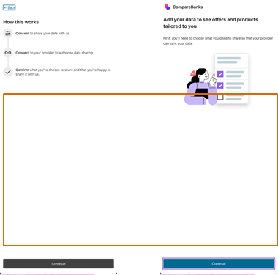
When information is expanded on this page, it becomes a “wall of text” and is hard to navigate. | 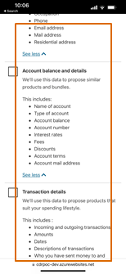

Issue theme 4: Visibility
Issue 4.3: No progress outline
There is currently no progress bar throughout the prototype. All consumers expressed a need for such indicator as it would help them feel in control.
When asked, consumers answered they were unaware how long the process would be, and where in the process they were.
Recommendation:  Add a progress indicator | Improve visibility of steps with indication of steps completed out of total steps and/or progress bar.
Evidence and examples
While there was an introduction about the steps that a consumer needs to go through, the lack of progress on subsequent screens gave them no visibility of progress.
While there was an introduction about the steps that a consumer needs to go through, the lack of progress on subsequent screens gave them no visibility of progress. | 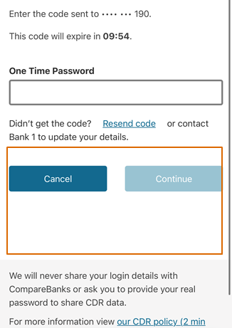

7 Recommendations
The following recommendations constitute an improvement plan for the Data Standards Chair (Chair). Each recommendation is provided with an assessment of the comparative importance, and necessary timeframe, using the Department of Finance’s Gateway Review methodology.
Recommendations 1-3 appear here, as they do in the Accessibility Obligations and Conventions Framework for the Data Standards Chair report (Background Report).

Recommendation 1: Whilst the CX Standards already mandate certain WCAG criterion, the Chair should consider more extensively incorporating WCAG into the Data Standards, the Data Standards artefacts themselves, and related products, to address their legislative obligations for Accessibility.

Critical, for immediate action.
Including by:
1.1 Maintaining compliance with the current version.
1.2 Having regard for WCAG’s further guidance, especially:
1.2.1 Mobile Accessibility;
1.2.2 Cognitive Accessibility;
1.2.3 Personalisation; and
1.2.4 Pronunciation.
1.3 Determining the Level of compliance (A/AA/AAA) required for each Success Criteria, which may involve consulting with:
1.3.1 AHRC
1.3.2 DTA
1.3.3 ABA; and
1.3.4 AER/ESC

Recommendation 2: Given the current reliance upon a Design System which is not fit-for-purpose, the Chair addresses the divergence from the GOLD Design System.

Essential, initiate consultation.
Options may include:
2.1 Advocating for the Design System Au, an open-source community, to build the necessary modules;
2.2 Seeking funding for these modules to be built, and advocate for their adoption into the GOLD Design System;
2.3 Acquiring the GOLD Design System as part of the function(s) of the Chair, and/or DSB.; or
2.4 (Preferred) Developing an independent Data Standards Design System that focusses on the needs of data sharing, and consent models, but incorporates components from other systems, such as the GOLD Design System where appropriate. This Design System would also include authentication in its scope.
As suggested in the Inquiry into Future Directions for the CDR (see pp.188-191), option 2.4 could, if appropriate, support consistency for data sharing approaches across the economy.

Recommendation 3: The Chair commissions a scoping-study into the development of Usability and Inclusivity framework(s) with the intent of addressing their legislative obligations.

Critical, for immediate action.
For reference, some common Usability and Inclusivity framework(s) include the Australian Banking Association’s Banking Accessibility Principles, Microsoft’s Inclusive Design methodology and Shopify accessibility and inclusivity design in practice.

Recommendation 4: The Chair, or the DSB, joins W3C in order to support the future direction of these standards.

Recommended, consider as part of forward planning.
Relevant forums in World Wide Web Consortium (W3C) provide a conduit for
- the DSB to influence the development of Accessibility standards and guidelines; and
- a direct interface for the Chair, and DSB, into the WC3 to influence the future direction of global standards informed by the on-going research of the DSB.

Recommendation 5: The DSB should maintain an Accessibility, Usability, and Inclusion capability in order to support appropriate Data Standards development, on behalf of the Chair.

Essential, conduct costings.
In accordance with obligations outlined in the Background report, the CX Data Standards must be brought up to alignment with the current WCAG version. Then, to ensure that CX Data Standards development maintains best practice, the DSB should create and maintain an Accessibility and Inclusion capability to:
- maintain CX Data Standards and guidelines for Accessibility, Usability, and Inclusion;
- manage local and international stakeholder and community engagement and relationships on Accessibility and Inclusion;
- operate, develop and maintain the Design System, especially its Accessibility components (if the Design System recommendation is adopted); and
- develop and maintain of the Usability and Inclusivity Framework, including providing support for its use by CDR participants; and
- support consistent, Accessible, and Inclusive data sharing methods across the economy, as suggested in the Inquiry into Future Directions for the CDR (see pp.188-191).

Recommendation 6: The Chair refines the existing CX Accessibility Standards in order to simplify and strengthen them.

Critical, for immediate action.
The Disability Discrimination Act (DDA) invokes a legal requirement for all information and services provided online to be usable and accessible to people with disabilities. As noted in the Australian Human Rights Commission’s (AHRC) guidance, any individual or organisation providing information or services online is subject to this requirement. The AHRC recommended adoption of WCAG2.0 for this purpose.
CDR participants are already required to make their online services accessible in accordance with the DDA. Therefore, it is recommended that the CX Accessibility Standards be revised to make CDR obligations consistent with these existing requirements. This recommendation also ensures that the Chair is complying with their legal obligations with respect to Accessibility, and that they are supporting Accessibility for organisations which make use of the CX Data Standards. To do this the Chair should consider replacing the existing CX Data Standards on Accessibility with a statement similar to:
All CDR participants MUST provide information and services that achieves two functional performance statements:
- Enable any person to locate identify, operate functions, and to access the information provided, regardless of physical, cognitive, or sensory abilities
- Maintain the privacy and security of any user at the same level regardless of the accessibility features of the content or service.
Provision of functional performance MUST be verified through conformance with current WCAG Level AA Success Criteria and where appropriate SHOULD confirm with relevant Level AAA success criteria.
These success criteria levels should be refined by the consultation undertaken through Recommendation 1.

Recommendation 7: Review, prioritise and address issues of Transparency, Clarity and Understanding and Visibility in the Consent Flow.

Recommended, consider as part of forward planning.
Below is a plan to improve Consent Flow, including actions and assessment of relative priority.

Theme | Issue | Action | Priority
Transparency | 1.1 Improve Understanding | CX research into comprehensibility of data sharing, as well as consumer perceptions regarding trustworthiness and transparency of CDR, as it relates to the Data Standards. | Critical
 | 1.2 Lack of trust |  | Critical
 | 1.3 Consider showing how the CDR recommends that participants address digital and physical safety. |  | Critical
 | - 1.4 Allow option for personalization |  | Essential
 | 1.5 General experience with sharing data online | CDR to lead the conversation and set the standard | Recommended
 | 2.1 Instructions | Provide clear instructions throughout the process | Essential
Clarity and understanding | 2.2 Language Use | Simplify language | Essential
 | 2.3Unclear visual content | Review visuals to match task and text meaning | Essential
 | 2.4 Financial and digital literacy | Omni-channel experience and education | Recommended
 | 3.1 Input controls | Make controls and buttons consistent | Essential
Consistency | 4.1 Inaccessible controls | Consumer Testing, for all features and functions available, during Production Verification and Acceptance Testing | Essential
Visibility | 4.2 Imbalance in white space | Bring balance to white space and content | Recommended
 | 4.3 No progress outline | Add a progress indicator | Essential

Appendix
Appendix A User Research Methodology 44
Appendix B Prototype outputs 51

Appendix A User Research Methodology

7.2 User research methodology

7.2.1 User research approach and considerations

Defining edge communities
In software development, edge case scenarios are those that are possible, but occur rarely or are outside the general user pathway.
We use the terminology ‘edge communities’ in order to define those who may have experiences outside the mainstream, or who’s needs may need specialist consideration and which not be met by testing with a mainstream audience.

Considerations for planning engagement with edge communities
Common UX research is conducted with mainstream communities, which can be defined as the general population and groups. Planning with edge communities requires some nuance from mainstream UX research, because it involves researching with consumers from vulnerable cohorts, disability and culturally and linguistically diverse communities. For example, recruitment companies are rarely used, and therefore we do not commonly develop screeners. Rather, recruitment in handled in house, informed by the following ten considerations:
1. Appreciate the context
People from edge communities may have vulnerabilities very different from mainstream users. Consider the context of their lived experience, especially regarding the research topic. As an example, with Aboriginal and Torres Strait Islander people, colonisation and the Stolen Generations have resulted in intergenerational trauma which could make research related to family dynamics particularly sensitive.
2. Trust is crucial
Working with people from edge communities requires trust built over time. This means you must be directly connected with the community or invited in by a trusted person through network. It also means any actions of follow ups (even if outside the direct research) must be carefully considered to maintain trust over time.
3. Networks provide a ‘front door’ for access
Building on trust, working within networks where edge community users are provides a ‘front door’ for finding the right people. This could include (as an example) putting an advertisement in a disability advocacy body newsletter looking for people with disability to participate. This also removes the need to identify the users specific access needs, as the network is self-selecting.
4. Be even more flexible, and allow extra time
Mainstream users are busy and have priorities other than research and so sufficient time to allow engagement is built into research planning. Even more so, to ensure your research is successful with people from edge case communities, allow extra time. This enables you to ensure they are fully informed, have free and prior informed consent and can schedule around their other needs. This flexibility should extend to all aspects of the user research. Take any burden you can from users and put it on yourself and the researcher – meet them where they are comfortable, at a time they are comfortable, record in a format they prefer.
5. Free and prior informed consent is non-negotiable
Ensure your users know EVERYTHING about the session beforehand with time to consider – what the research will cover, who will run the session, how the research will be conducted, where it will be conducted, how it will be recorded, who will have access to research material after the fact (including data sovereignty considerations), how the user will be compensated for their time and knowledge, what the opt out procedures are and what after research care is available to ensure cultural and psychological safety. Only once the user has this information can they make a considered decision to participate.
6. Consider Intersectionality
Consider intersectionality within edge case communities. For example, a user may be from a culturally and linguistically diverse (CALD) community, be over 65 years in age and live in a remote area. Because of this breadth of experience, you can gain a lot of insight for your product or service in a single engagement.
7. The phone is your friend
In addition to working with networks to find the right people to engage with, PIC and CFID also maintain our own databases with contacts for users. In our shared experience, getting on the phone and engaging directly with people is far more fruitful than any other engagement method. This is the same throughout the research process, from planning to conducting to follow up. Researchers often follow up with results of the study for participants, or a summary document outlining findings.
8. Consider prior research or consultation burden
Aboriginal and Torres Strait Islander people carry a high consultation burden from government and researchers. Consider if similar work has been done before, and how you might access to minimise burden on users. Also, consider if users have participated in research before, as this may affect the insights you can gather.
9. Know your own privilege, and bias
Working with edge communities can present challenges to the researcher that you will not find outside the mainstream. Consider your worn privilege and bias. Consider how you will deal with feedback. Consider what you will do if the research goes in a direction that puts your user or your researcher in a position where their cultural or psychological safety is compromised. Consider how you will debrief yourself and your team, and any after care required. Have a plan for this beforehand.
10. Be prepared for follow up
Like in mainstream research, once you build trust with your user, they will open up to you. The research may go in a direction you hadn’t planned. The user may present challenges outside scope or which you cannot solve. Be prepared for additional follow up to pass these on or action them, to maintain and build trust.

7.2.2 Inclusive usability testing approach

Approach | Inclusive Usability Testing
Methods | - User tasking  - Semi-structured interviews  - Behavioural observation
Artefacts and Instruments | - Coded prototypes  - Discussion guide  - Note taking log
Participants | 10 edge community people were engaged to test the CDR’s usability and accessibility, inclusive of vulnerable segments of the community. A total of 15 hours of interviews were conducted. Participants were renumerated for their time and participation.
Team Roles and Responsibilities | PIC and CFID co-designed tasks, instructions and discussion guide for the testing sessions for The Department’s review. The combined team facilitated testing sessions, synthesise and document findings for delivery to the Department of Treasury. The team comprised of:  - Lead Inclusive Tester (CFID) - developed a testing approach, facilitated the testing process, led the analysis and documented the user testing report.  - Support Tester (PIC) - Their role is to support the testing process, collect notes, and support the documentation of the report. For cultural safety purposes, PIC provided Indigenous staff during testing sessions with Indigenous participants.
Equipment and Setting | Testing was conducted in person and/or remotely depending on participant proximity to the testing facilities in Melbourne and Sydney. For in-person testing, we provided a computer or tablet or mobile phone for participants to undertake the screen flow tasks. For remote testing sessions participants were required access to Wi-Fi or cellular data coverage, as well as a video-capable computer or tablet or mobile phone for testing purposes. Facilitators utilised screen sharing functionality to guide participants through the screen flows. Video recording was undertaken to support notetaking and aid with analysis.

Research objectives
This Usability Testing (UT) research will be focused on the overall experience of users engaging with CONSENT, AUTHENTICATE, and AUTHORISE experience flows interacting with a new CDR Flow prototype in code. This testing seeks to understand the hurdles that might prevent maximised:
- Accessibility - a measure of how accessible a service is to users regardless of their digital confidence and access to a digital environment. This includes users in remote areas and users with different devices.
- Usability - a measure of how well a specific user in a specific context can use a product/design to achieve a defined goal effectively, efficiently and satisfactorily.
To help identify issues consumers are likely to encounter and provide insights to improve the design and function of the screen flow from a usability and accessibility standpoint., our testing will primarily focus on validating the below customer experiences across the CDR Consent Flow. An example of the prototype can be found here.
- Collection and use consents:
  - Be as easy to understand as practicable, including by use of concise language and, where appropriate, visual aids.
  - Provide the consumer with the accredited person’s name and accreditation number
  - Conformance to other “MUST” and avoidance of “MUST NOT” item requirements in the relevant CX Guidelines.
- Authenticate and Redirect with One Time Password
  - Ensure that the CDR participant’s CDR policy is readily apparent and easily accessible.
  - Clearly communicate to consumers that services utilising the CDR do not need access to consumer passwords for the purposes of sharing data.
  - Conformance to other “MUST” and avoidance of “MUST NOT” item requirements in the relevant CX Guidelines.
- Authorise to disclose:
  - Ensure the data holder has provided the consumer the types of CDR data for which the data holder is seeking an authorisation to disclose.
  - Ensure the data holder provides information to the consumer about the period of time to which the CDR data that was the subject of the request relates.
  - Conformance to other “MUST” and avoidance of “MUST NOT” item requirements in the relevant CX Guidelines.
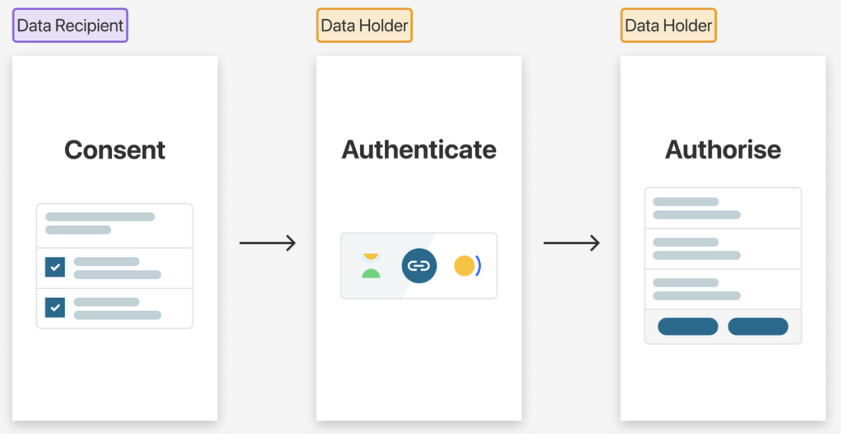

Participants
Testing will be conducted one-on-one with people simulating an online banking experience. Here are some characteristics about who we will seek to recruit:
- 10 individual users total
- A mix of urban, rural and remote residents
- An even gender balance
- Aboriginal and Torres Strait Islander consumers
- Other culturally and linguistically diverse consumers
- A range of abilities including elderly, blind / low vision, deaf, mobility, cognitive and sensory will be represented
We will utilise our extensive networks in community to recruit.

Consent forms and incentive
All participants were paid for their contribution. Payment is in the form of gift cards ($100 for 90 minutes). This can be sent electronically or physically. We also use a consent form that details how the testing will be conducted and what information will be shared and with whom.

Content to be tested
- Link - https://cdrpoc-dev.azurewebsites.net/

Testing format
- In-person or Virtual (zoom)
- Desktop or tablet, mobile
- Testing sessions occurred over 90 minutes with the first 30 minutes dedicated to introductions, project background and informed consent conversation and the remaining time dedicated to tasking, interviewing and observation to evaluate the usability and accessibility of the CDR Flow.

When
- Between 13/06/22 - 24/06/22

Facilitators
- Lead Facilitator (CFID) Alina Butolina; Facilitator (PIC) - Cassandra Parkin.

Reporting Results
The report was provided at the conclusion and analysis of the usability test at an agreed time. It consists of a report and presentation of the results, objective evaluations, and specific usability and accessibility problems.

Approach
Testing consisted of a structured task-based system testing and analysis, involving the participating to perform a series of experiential tasks with the system. Participants will be prompted to “Speak Aloud” during their completion of tasks. Each task will be followed by metrics capture and open-ended questions discussing their experience.
An open structure generated discussion, allowing users to provide their general impressions and feedback on experiencing the overall document.
Areas of difficulty identified were discussed to identify ways to improve the user experience.

Task sequence (usability steps)
TASKS (in response)
- Pre-consent – setup the experience and value proposition
- Review the Consent prompts and instructions, then “Consent”.
- Review and navigate the Authenticate Login prompts and instructions.
- Review and confirm the data request, then “Authorise”

Session discussion guide

Introduction
- Time taken: 30 minutes
· Good afternoon/morning! Thank you for agreeing to take part in this research with us. (Add some preamble to build rapport with participant)
· Project background
o The Department of Treasury have engaged in this work with us as part of their commitment to inclusive practices and to gaining diverse feedback on their new data sharing consent flow. Your involvement in the study will help shape the usability and accessibility of their processes.
o You have been invited to take part in this research because the Dept. seeks input from a diverse range of communities and experiences. Your experiences will be highly valued as we believe your interaction with the system can help review the usability and accessibility of the system.
· How the session will run
o What we’ll be covering today is essentially, how you interact with the consent flow to identify what works and what not. And pull out some recommendations to enhance the experience.
o I will be walking you through a series of tasks that will test the varying functions and actions of the consent flow.
· Recording and confidentiality
o Purpose of video recording and transcription (CfID and PIC research team to analyse and note take post session)
o Everything you say here is confidential and the information we collect will be de-identified after the interview (except in the case of video recordings)
· Session considerations
o If you ever find yourself uncomfortable with any of the questions of tasks let us know and we can skip them and move on to the next task. If you need any breaks, please let us know in between tasks.
o This session is not testing your personal skills but rather the functionality and usability of the product. There are no right or wrong answers. We are aiming to improve any potential user issues that arise in these system analysis sessions and improve overall user experience.
· Consent and information form – confirm participant has signed the form and understands the contents
· Incentive – virtual gift card after session?
· Any questions before we begin?

Pre-questions:
- Warm-up – Discuss a little bit more about yourself and what you do?
- What does providing consent to data mean to you?
- What are the important elements to consider when providing consent to share your data?
- What applications would you provide consent in sharing your data? And which applications do you already provide consent to share your data?
- What has been your experience with online consent to data sharing? Any examples of good or not so good experiences?

Scenario:
OK, so imagine you are thinking about switching your credit card or applying to get a new credit card. There is a mobile application that can help your get a better deal by accessing your personal banking information. By analysing your personal banking information, the application will be able to provide you with a range of different banking products that suit you.
We are going to test the consent feature in this application with you by asking you to click through a series of tasks in the consent model.
As you walk through the screens, feel free to speak your mind and how you are feeling.
This is not a test on you, but on our design of the consent flow

TASK 1: Review the Pre-consent prompts and instructions, then “Continue” to CDR Flow.
Prompt: Read the information on each of the pages and when comfortable continue onto the next set of screens
Assess:
Does the participant see the benefit and risks in continuing onto the state stage of the consent flow?
Does the participant understand the consent process they are about to engage with before entering the next stage?

TASK 2: Review and navigate through the Consent flow of screens prompts and instructions.
Prompt: Select a provider to share data, select your data to share and the data groups you want to provide access with and consent to the collection and use of your data.
Explore the option of denying and cancelling the request to share
Assess:
- Does the participant understand how consent is framed through the screen?
- Can the participant navigate through the various screens?
- Does the participant have a sense of where they need to select to progress in the consent flow?
- Do the users understand the language used in how we communicate data clusters and fields?
- Do they feel confident in their decision?

TASK 3: Review and navigate the Authentication screen prompts and instructions, then “Continue”.
Prompt: Login to bank using authentication screens, type any number as your identifier and imagine you received a onetime password on the phone to input as part of the authentication process. Follow the prompts to complete your authentication process.
Assess: Does the participant understand that they are taken to a login to access their banking data and how these fits into the consent model?
Does the participant feel safe and have trust in this authentication process to access their data?

TASK 4: Review and navigate the Authorisation screen prompts and instructions, then “Continue”.
Prompt: Once you have logged in, select the accounts you want to share, confirm what and authorise what data you want to share to complete the consent flow. Completing this set of screens is the final part of the consent model which will take you to a recommended product comparison tool based on the data you have provided. They can also try and cancel sharing at any point in time.
Assess: How does the participant feel after completing this stage?
Post questions:
- Based on this experience, would you be likely to use a digital service that followed this Consent flow?
- CX metrics introduction – as part of the testing process we are going to do an activity where we ask you a series of questions on what you have experienced to and test whether you feel like you have given informed consent in this testing experience

Appendix B Prototype outputs
The developed prototype was used for the Consumer Testing of ten participants with a range of disabilities and spread across a range of demographic attributes e.g., Indigenous, Cultural and Linguistically Diverse and English as a Second Language cohort. The completed prototype and all its supporting assets have been shared with DSB to be uploaded to CDR’s CX Guideline Notion knowledge portal. Depending on the outcomes of the project, Treasury may decide to publish the open-source code to make it more tangible for industry stakeholders to implement their own CDR Flow that meets the current Standards and Guidelines.

The coded prototype of the CDR consent flow included a “happy path” experience of the Consent Model - Consent, Authenticate and Authorise flows. The following table documents the three stages and build assumptions for the development of the coded prototype.

End to End CDR Consent Flow Shows the three stages of the CDR flow in a clickable prototype. Shows the three stages of the CDR flow in a clickable prototype.
Consent  Detailed Design documentation  In-scope pages  - 00/01/02- Collection and use consents - default example  Out-of-scope pages  - ↳ 03a- ADR uses outsourced service providers  - ↳ 03b- Sponsorship arrangement  - ↳ 03c- CDR representative arrangement  The Figma prototype includes documentation layers that can provide more information and detailed design specifications for the build process.  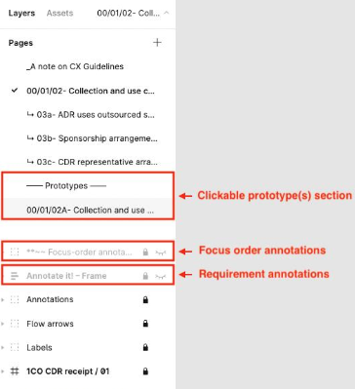 | Authenticate  Detailed Design documentation  In-scope pages  - 00/01/03 - Redirect with OTP  The Figma prototype includes documentation layers that can provide more information and detailed design specifications for the build process. | Authorise  Detailed Design documentation  In-scope pages  - 00/01/02- Authorise- default example  - 08- Cancellation  Out-of-scope pages  - ↳ 03- Unavailable accounts - All accounts can be shown  - ↳ 03a- Unavailable accounts - Unavailable accounts cannot be shown  - ↳ 03b- Unavailable accounts - No accounts can be shown  - ↳ 04- Data related to one or no accounts  - ↳ 05- Profile selection  - ↳ 06- Duration  - ↳ 07- Layout variation  The Figma prototype includes documentation layers that can provide more information and detailed design specifications for the build process.

Background in developing the Figma prototype
The components of the Figma prototype have been built from adapting the GOLD Design System to DSB Design Library. Because the Australian Design System’s components have been built, tested and accredited as being Accessibility compliant, it is assumed that the CDR team developed their prototypes with Accessibility in mind. CDR have applied their own Accessibility and CX lens in developing the prototype.

Build assumptions
Due to the limited timeframe and constraints for the project PIC and Treasury documented the following prototyping assumptions:
- Developed web application built on React is for a mobile experience
- Aligned to the Figma flows and screens developed by the DSB team.
- Aligned with the same styling, fonts and imagery as specified in the Figma prototype.
- Excluded any interaction elements that are not specified in the original Figma flows - e.g., popovers, warning and info validations.
- Excluded connections to any API’s and external links.
- Initially built and deployed on PwC’s cloud Azure infrastructure for the build and testing process for rapid development and deployment.

To make testing purposes more tangible for users, a scenario context was developed to inform the text and copy in the prototype. Because Treasury identified the application of a generic Banking product comparison application, the development team applied CDR’s Banking Data language standard to the prototype and its relevant screens.

Storybook was used to build User Interface components to develop and update a library of CDR components. Each User Interface component was built and tested to align with CX standards, accessibility criteria of the CDR Figma flows and screens. The use of Storybook enabled the development team to streamline page development, accessibility testing, and documentation. Collaborating in a cross-functional teams, the development team implemented new features and resolved issues from the testing and accessibility review process. Azure DevOps was used to manage, build, test and deploy our code to the dev-site for testing online through the Azure Web Apps.

Tools and technologies:
- Node.js
- ReactJS
- Storybook
- Jest
- Azure DevOps
- Azure Web Apps.

Deliverables
  - Prerequisites: Download and install Node.js
  - Download and unzip the prototype code from Notion
  - In the project directory
    - Run `npm install` command to install all dependencies.
    - Run `npm start` command to run the app in the development mode. Open http://localhost:3000 to view it in your browser. The page will reload when you make changes. You may also see any lint errors in the console.

To view the storybook, run `npm run storybook’ command to view all UI components we used in this project outside the application in an isolated environment. Open http://localhost:6006 to view all stories in your browser.
To test all components, run `npm test’ command to launch the test runner in the interactive watch mode.

https://www.humanrights.gov.au/dda-guide-whats-it-all-about
https://www.finance.gov.au/publications/resource-management-guides/guidance-assurance-reviews-process-rmg-106
An industry standard term, sometimes called Happy Flow. A happy path is a default scenario featuring no exceptional or error conditions. In the context of testing a prototype, this means the test is completed using known input, which executes without exception and produces an expected output.

